RETRIEVING ENTITIES
CAN SKIP THIS PART AND LOOK AT DISHES PART

- File Needed:
  - Restaurants.Api/Controllers/RestaurantsController.cs
  - Restaurants.Application/Restaurants/RestaurantsService.cs
  - Restaurants.Domain/Repositories/IRestaurantsRepository.cs
  - Restaurants.Infrastructure/Repositories/RestaurantRepository.cs
  - Add scoped in Restaurants.Infrastructure/Extensions/ServiceCollectionExtensions.cs
  - Create a new Restaurants.Application/Extensions/ServiceCollectionExtensions.cs (almost similar with Infrastructure module)
  - Add nuget package Microsofts.Extensions.Logging.Abstractions
  - Extract interface for RestaurantService.cs under application module
  - Edit program.cs must AddControllers (missing in the video)
    - builder.Services.AddControllers();
    - remove weather forecast part
    - add app.MapControllers(); before app.Run();
  - Edit Restaurants.Api.http in Api module
  - Run the web api application and test the api In UI or in the endpoint

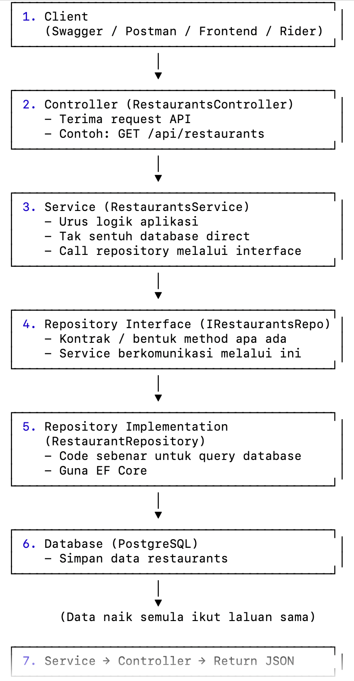

- First, we need to create controller because Controller is the entry point for handling HTTP requests
